SELL MY HOME
You are to research the real-estate market in NYC (use websites of local real estate brokers).
1. Select a property you find
2. Design a housing-magazine advertisement for the property, displaying the housing graphics, including descriptions, listing agents, prices, contact information, and more.

Design a Magazine Ad
1. 8.5 x 11" (Illustrator)
2. All 4+ images must be professional looking
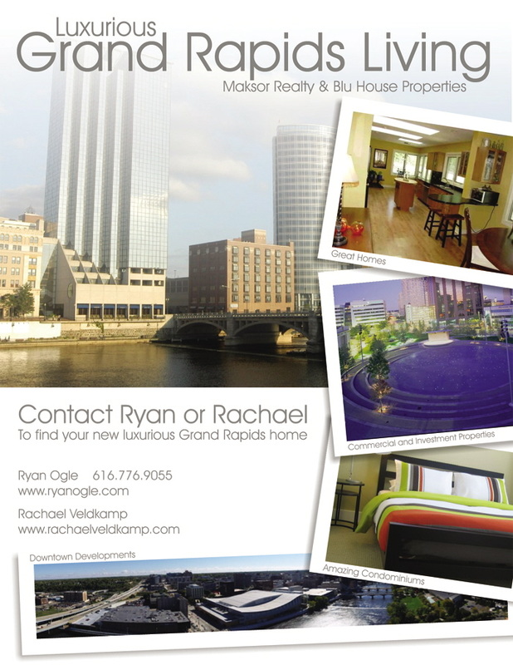
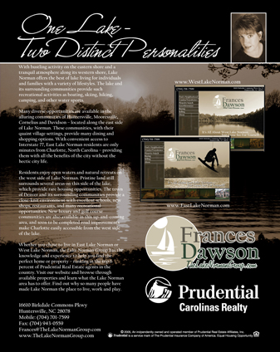
3. Document must include a background

Font Tips
- Choose easy to read fonts (i.e., Garamond, Helvetica, Times New Roman, or Century).
- Use a sans serif font, such as Arial, for captions or small type.
- Limit your font choices. Using more than two types of fonts will make your brochure messy, unprofessional or playful.
- Use highlighting techniques – bold, italic and bigger font size — instead of varying font styles.
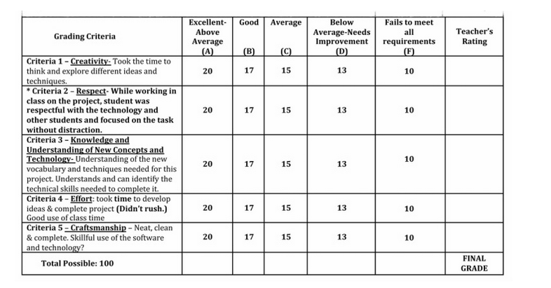
- Use a bigger text size for headlines and calls to action. Although not always, font size can be relevant to the importance of information.

