Find and Replace Computer Applications

Overview
Word offers several options for locating specific content in your document. You can search for and replace items such as text, images, captions, bookmarks, or certain types of formatting such as paragraphs or page breaks.

Instructions

- Open find_replace.doc on the class web site.
- Find and replace the following words:
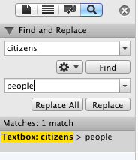
citizens > people
Mount Carmel Area School District > MCASD
notable > famous
mathematics > math
Mount Carmel Area High School > MCAHS
District > MCA
Department of Transportation> DoT
Pennsylvania > PA
modern > contemporary

- Find the following words and use the thesaurus
to replace them.
requirements
transfer
activities
casual
achievement
decline
magnificent
neighboring
built
incorporated
completed
comprised

- Insert a header that contains your name and period number.
- Save as REPLACE.

