Is the Logo Change an Improvement?
The following Internet articles were included for your reference. They will help you fill in the table.
https://www.businessinsider.com/corporate-logo-changes-2015-10
https://www.businessinsider.com/shocking-drastic-logo-changes-2013-4
https://www.businessinsider.com/compare-the-original-and-most-recent-logos-of-19-top-companies-2016-5#8-mozilla-firefox-8
https://www.inc.com/sophie-downes/best-worst-company-logo-rebrands-2018.html
https://time.com/collection-post/4571830/top-10-logo-changes-2016/

LOGO/Company | What changes or updates were made? | Is this version better than the old? | Explain why…
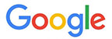
Google
IHOP
Verizon
Spotify
Facebook
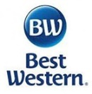
Best Western
Instagram
Weight Watchers
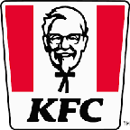
KFC
Mr. Coffee
Logitech
Lenovo
Vevo
Netflix
Pandora
Honest Tea
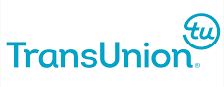
TransUnion
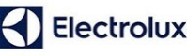
Electrolux
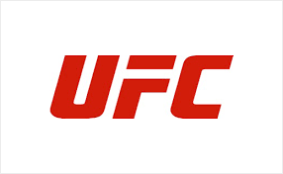
UFC
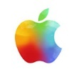
Apple
Yahoo
IBM
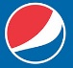
Pepsi
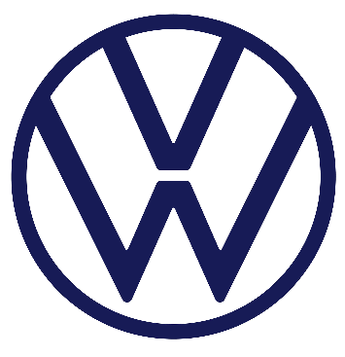
Volkswagen
Kate Spade
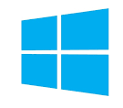
Windows
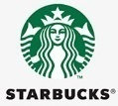
Starbucks
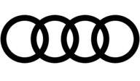
Audi
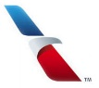
American Airlines
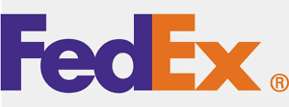
Fed Ex
Discovery
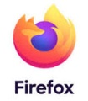
Firefox
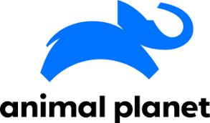
Animal Planet
Best Buy
Staples
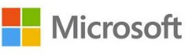
Microsoft
Livestrong
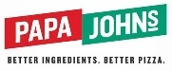
Papa Johns
Fisher Price
Uber
Dunkin
Travel Channel

