****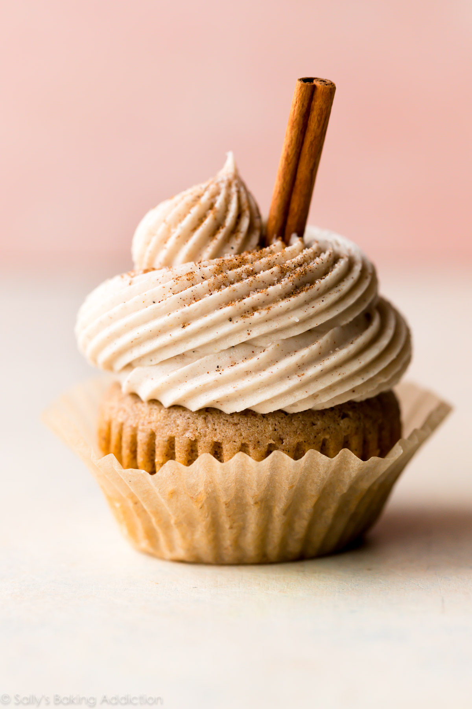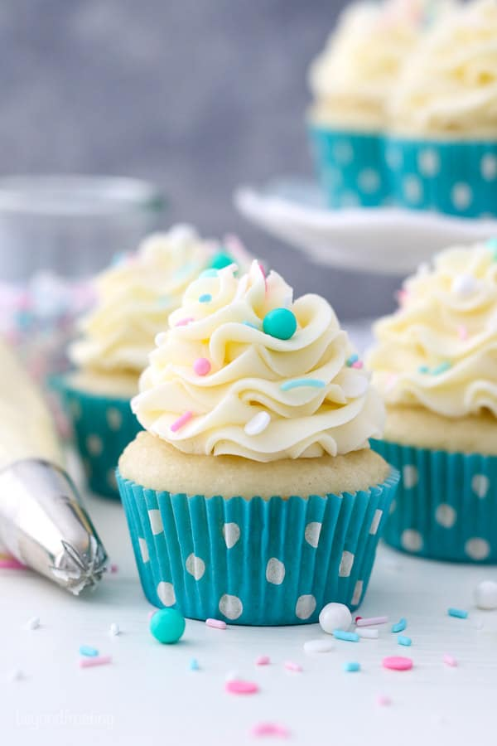

* Nationwide shipping
* Catering parties/weddings
* Bakery contests
* Include a paragraph about the owners that lists their experience and education.
* Add a paragraph about the history of your bakery.
* Include at least two photos.
* Offer at least three classes. They could range from creating cupcake bouquets, to learning how to make your own frosting. List the price and date/time of each class.
* Add a “sign up now” button.
* Include a picture of your decorated cupcake!
* Create a page that has specials for each day of the week. Include prices.
* Provide customers with a list of all the cupcakes. Include a one line description, along with the price.
* Include photos
* Add additional bakery items available at your store. No prices needed. Include a minimum of two additional items.

* Introduction – 1 paragraph

Welcome to Cupcake Genius…

* A minimum of three photos
* Add a mailing list button

Web site address:

Owner’s name:

Location:

Contact info:

Color scheme:

*You, as a web designer, will develop a site for* ***Cupcake Genius****, a cupcake and specialty bakery, located in a small city with the population around 300,000.*

Use this form as your storyboard. The information provided in this section must be located somewhere on your site.