Photoshop CEREAL BOX PROJECT

Create a “parody” box OR (if you have no ideas) create a “spirit” box centered on your favorite school sport, club, class, or activity. Any good idea works. Have fun!

Check out these “Photoshop” Parody boxes. This was my inspiration!
So clever-- http://www.photoshopcafe.com/contests/contest-6-finalists.htm

PLANNING
- Come up with a company name, logo, and colors for your project. Your company logo must include a “unique font”, text warping, and incorporation of at least one shape and/or dingbat font. (Be creative)
Example 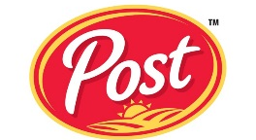

- Decide on a catchy name for your cereal. Some examples: Volleyball Flakes; Yearbook Clusters; Choir-O’s; FCCLA Loops (or parody)

- Collect artwork and shapes/dingbats/brushes. This project must utilize non-standard shapes. You can use/load custom shapes, draw with the pen tool, install a dingbat font set that consists of shapes, etc. At least FOUR different shapes or special characters/embellishments must be used on the box. And, YOU must be on the box someplace (but you do not have to be on the front; internet pictures may be used as long at the quality is good).

- Design the cover for your cereal box or package. This includes front, back, and sides. The top and bottom flaps are optional, though you might want to at least put your logo or some simple shapes on those. You may use nutritional information from a box of cereal or there is a blank label on the Z drive (there are also a few bowls of cereal or you can find your own or take your own). You must have:
- Nutrition label (side)
- Information about the cereal (side) with embellishments/shapes/dingbats
- Picture of cereal (front)
- Activity and/or games to play or information on free prize inside; decorated with shapes/dingbats (back)

SCORING GUIDE
Requirement | Points Possible | Deducted
Professional logo designed (unique font, use of at least one shape, text warp, readable) and used on front of box | 15
SIDE L: Nutrition label included on side panel | 10
SIDE R: Information about cereal is readable, creative use of fonts, and use of shapes/dingbats/embellishments (non-standard) | 10
BACK: Includes activity and/or games to play, decorated with shapes/dingbats, overall professional look (quality matters; make sure all text is readable) | 15
FRONT: Name of cereal is creative, in unique font, and has at least two styles applied (fX) List which: ________________________ | 5
FRONT: Cover image is clear, quality of selection for cereal and subject, and overall professional appearance | 25
TOTAL 5 pts deducted if not assembled properly! | 85

Student Name:_______________ Name of Cereal: _____________________

Page Setup—Create a Full Letter Landscape size document—US Paper/Letter 11 x 8 ½”

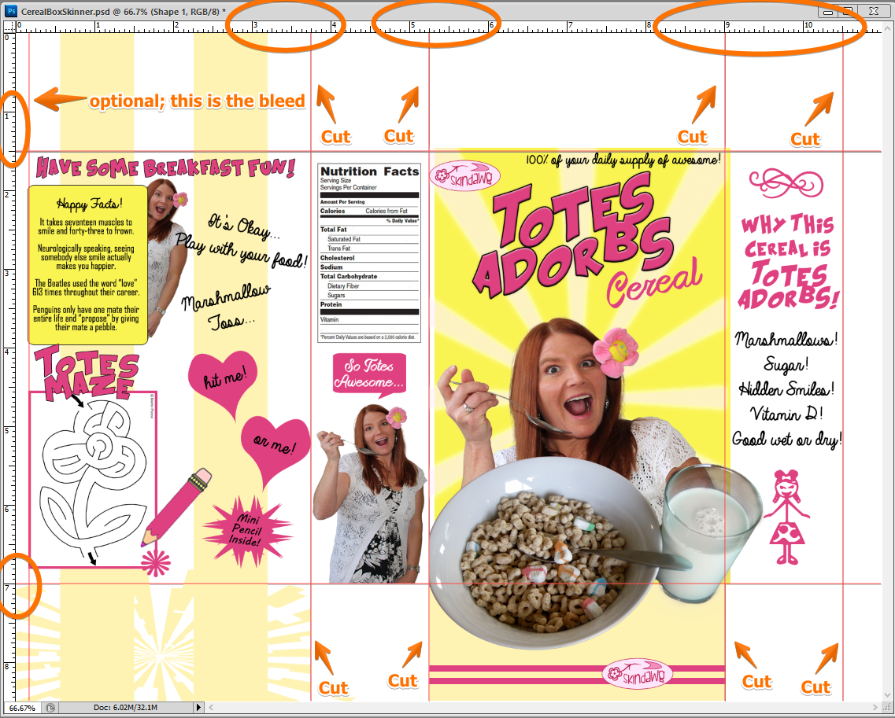

- Set Vertical guides at 3.75”, 5.25”, 9”, and 10.5”. There is an edge you can’t print to so you might drag a guide at .25” or so, but that’s optional. Do not cut there!

- Set Horizontal guides at 1.5” and 7”.

- You will print on CARD STOCK in landscape (Print Settings; Paper type-Cardstock; be sure to put that in the manual tray of the printer first!). You may have to click “Proceed” to print as it knows it cannot print to the edge of the page and will likely warn you.

- After printing, you will cut only the 8 short lines. You might want to draw faint lines with the line tool on those 8 spots just so you have something to help you cut straight as the guides do NOT print. Assemble your box and tape (neatly) or glue the edges. If you want to put a prize inside, I won’t stop you.
