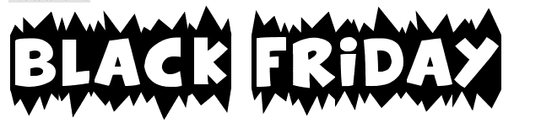

https://www.bfads.net/Infographic-Black-Friday-Shopping-Survey-2016

- According to the infographic, what are the top three items consumers are most excited for on Black Friday?

- What age group has the least amount of Black Friday shoppers?

- The number of shoppers that shop on Black Friday because of the low prices, increased by how much from 2012 to 2016?

- _____________ of buys used cash as payment on Black Friday.

https://blackfriday.com/trends-and-predictions#trends-and-predictions

- What is the average total of Black Friday sales over the past three years?

https://www.forbes.com/sites/gordonkelly/2017/11/13/walmart-vs-amazon-best-black-friday-2017-deals-sales/#3032e3521684

- Where does the author suggest one buy a high quality HDTV this year?

- Last year, Patagonia, a brand that specializes in outdoor clothing and gear did what on Black Friday? (Look it up.)

